**ASSIGNMENT 2 PROBLEMS ON CONTROL STATEMENT**

Write a Program to Find the sum of series 2+4+6+8.....+N.

PROGRAM

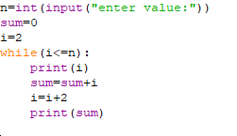

OUTPUT

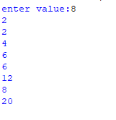

Write a Program to Find the sum of series 1+11+111+1111.....+N.

PROGRAM

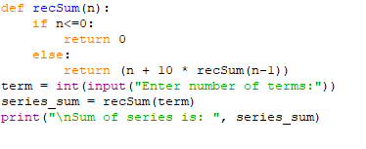

OUTPUT

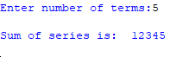

DOWNWARD FULL PYRAMID PATTERN OF STARS:

PROGRAM:

num=int(input("Enter the number of rows: "))

for i in range (num,0,-1):

for j in range(0,i):

print("*",end=" ")

print()

OUTPUT:

Enter the number of rows: 6

* * * * * *

* * * * *

* * * *

* * *

* *

*

>>>

ARMSTRONG NUMBER:

PROGRAM:

n=int(input("Enter a number: "))

sum=0

temp=n

while temp>0:

d=temp%10

sum+=d**3

temp//=10

if n==sum:

print(n,"is an Armstrong number")

else:

print(n,"is not an Armstrong number")

OUTPUT:

Enter a number: 153

153 is an Armstrong number.

INVERTED PYRAMID PATTERN OF NUMBERS:

PROGRAM:

rows=5

b=0

for i in range(rows,0,-1):

b+=1

for j in range(1,i+1):

print(b,end="")

print("/r")

OUTPUT:

11111

2222

333

44

5